Question 5

* In Cisco Packet Tracer, configure NAT on a router to allow internal devices (192.168.1.x) to access the internet.
* Test connectivity by pinging an external public IP.
* Capture the traffic in Wireshark and analyze the source IP before and after NAT translation.

Approach

Let’s say that the server is the internet as of now. Make the below connection and assign ip address.

For PC1 192.168.1.2

For router 192.168.1.1 (GB0/0/0)

For router 203.0.113.254 (GB0/0/1)

For server 203.0.11.1

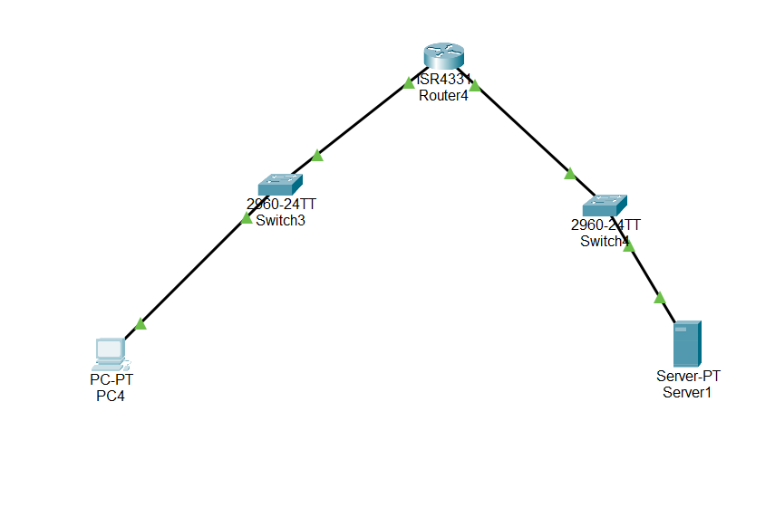

Now configure the router saying that 203.0.113.254 contains outside nat and gb0/0/0 contains inside ip nat

Now check for nat translation table and also make sure to assign static nat to pc using below command

Ip nat inside source static 192.168.1.10 20.20.20.2

For PAT (Port address translation (Dynamic public address))

Ip nat inside source list 1 interface GigabitEthernet0/0/0 overload

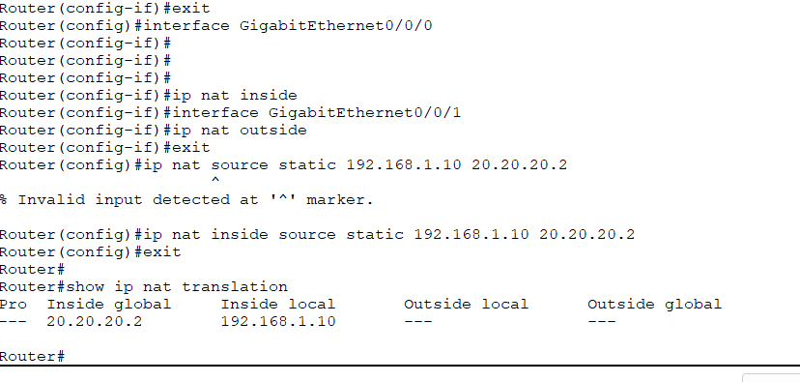

Now try to ping the server from the PC

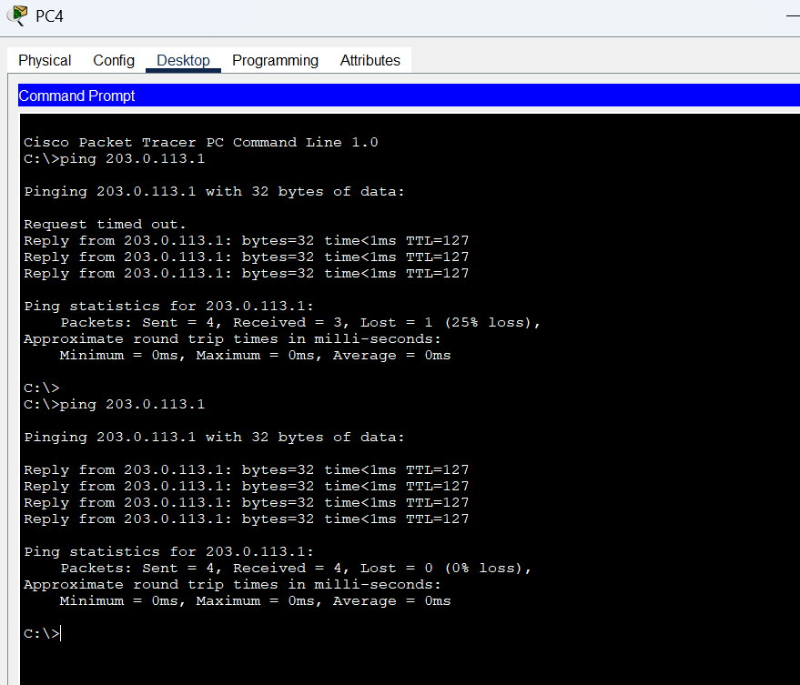

Check the source ip before NAT

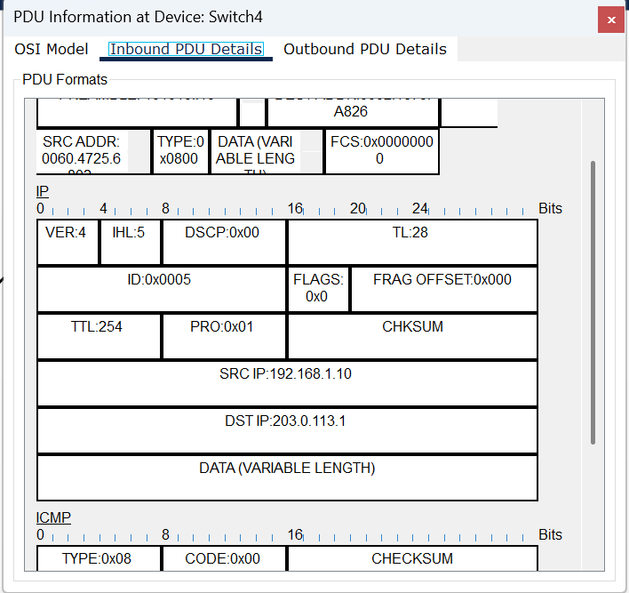

Now check the source ip after nat.

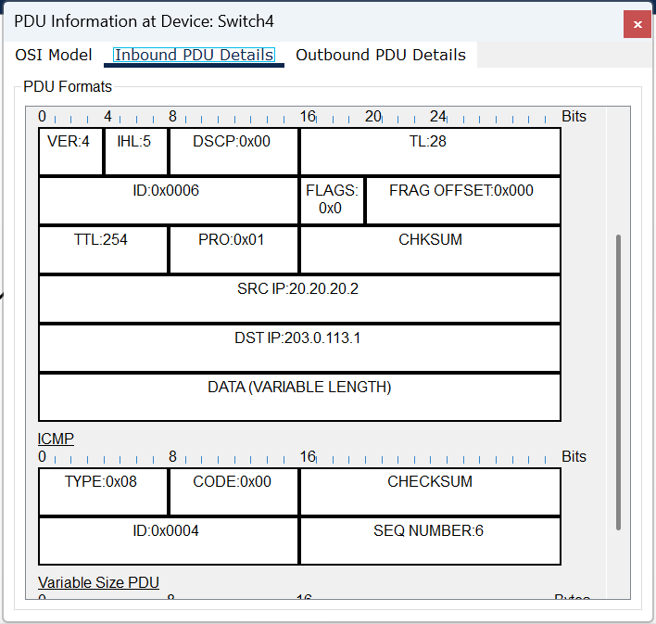

Above two packets are sent from same PC